**Module 1: Introduction to VBA & Macros**

* What is VBA, advantages of automation

VBA (**Visual Basic for Applications**) is a programming language developed by Microsoft.  
It is mainly used to **automate repetitive tasks** in Microsoft Office applications like Excel, Word, Access, PowerPoint, and Outlook.

For example:

* In **Excel**, VBA can automate data entry, formatting, calculations, and report generation.
* In **Word**, it can generate customized letters, reports, or documents automatically.
* In **Access**, it helps manage databases efficiently.
* Advantages of Automation with VBA
* Saves Time & Effort ⏱️

Automates repetitive manual tasks (e.g., monthly reports, data cleaning, invoice generation).

* Increases Accuracy ✅

Reduces human errors caused by repetitive typing or copy-pasting.

* Improves Productivity 🚀

Employees can focus on strategic work instead of manual, time-consuming tasks.

* Custom Solutions 🛠️

VBA allows you to build customized tools like dashboards, forms, and macros tailored to business needs.

* Integration Across Applications 🔗

Can connect Excel with Outlook (send automatic emails), Word (generate documents), or Access (fetch data).

* Cost-Effective 💰
* No extra software needed—just Microsoft Office.
* Scalability 📊
* The same VBA code can be reused for multiple files, processes, or even across departments.

👉 Example:  
If you prepare a monthly sales report, instead of spending hours cleaning data, formatting charts, and creating summaries, you can just click a macro button and let VBA do everything in seconds.

* Recording simple macros in Excel

1. Save as excel file- Give Name of file ,

than-“Excel Macro-Enabled Workbook(.xlsm)”

1. Go to developer Tab
2. Click on record macro
3. Give name of macro+ Shortcut key – click ok
4. Preform Task what ever you want and click on stop recording macro
5. Now use this macro whenever you need, it will complete your task in a seconds.

* Macro security settings & enabling Developer tab

Macros (VBA programs) can be powerful, but they may also contain harmful code (like viruses).  
That’s why Microsoft includes **security settings** to control how macros run.

You can configure these in:

**Excel/Word/Access → File → Options → Trust Center → Trust Center Settings → Macro Settings**

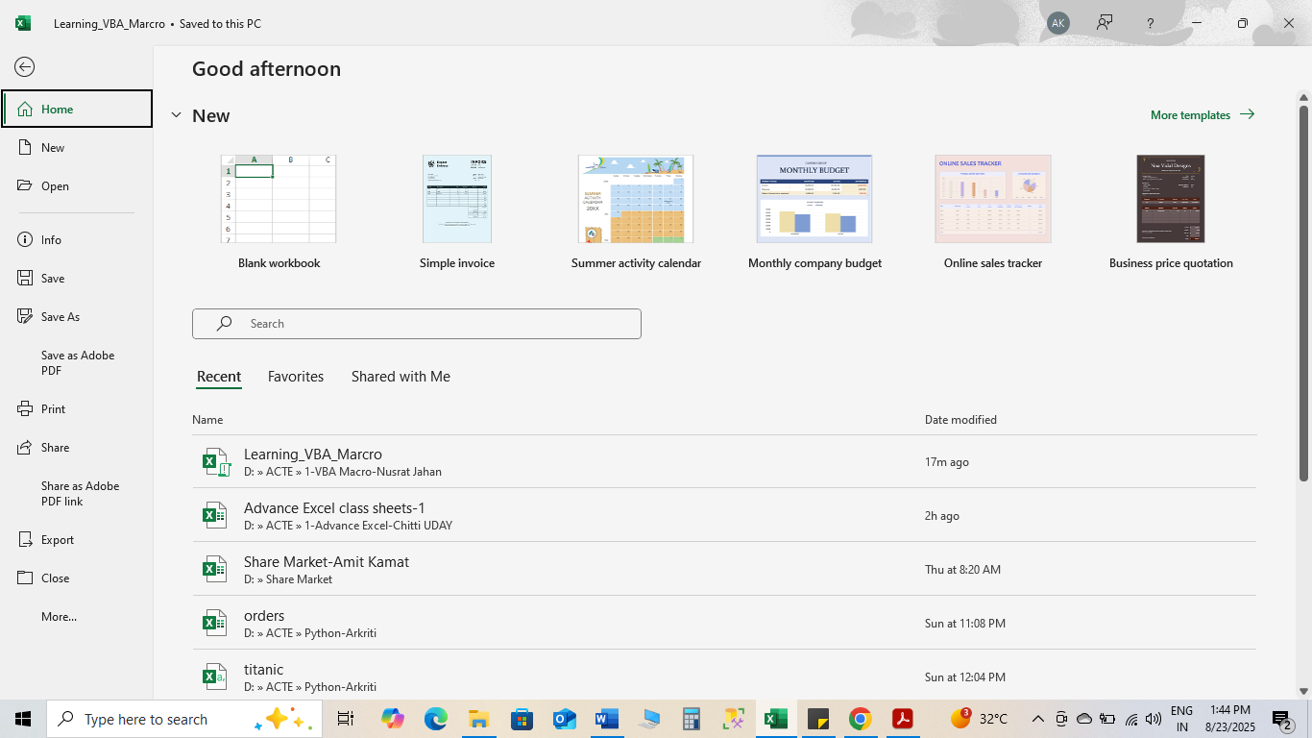

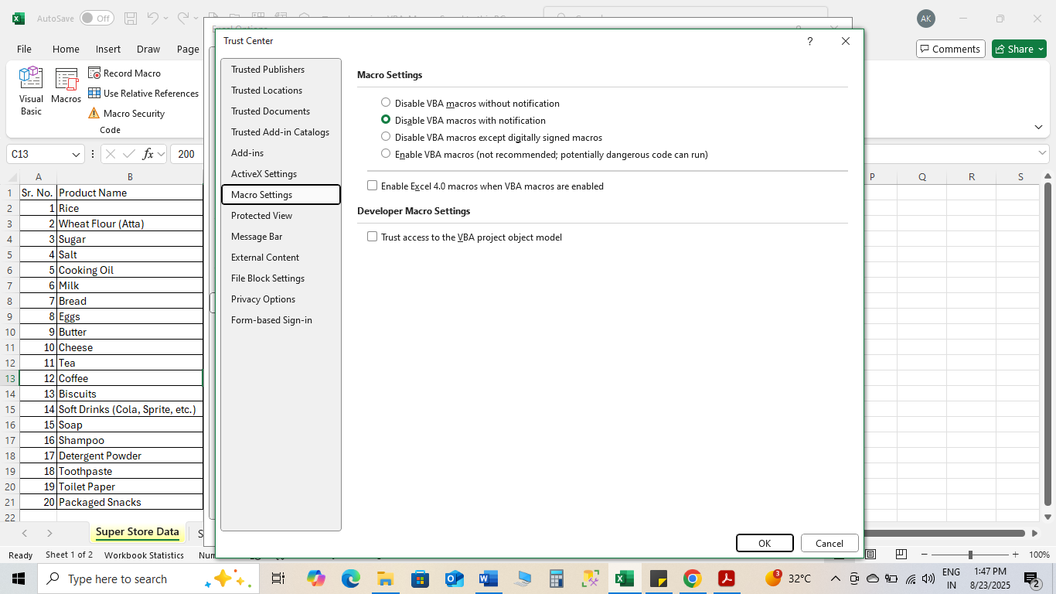

**Levels of Macro Security**

1. **Disable all macros without notification** 🚫
   * All macros are blocked silently.
   * The user won’t even see a warning.
   * Safest, but you can’t run any VBA unless you manually enable it.
2. **Disable all macros with notification** ⚠️
   * Macros are blocked by default, but you’ll get a **yellow security warning bar**.
   * You can choose to enable macros for that file.
   * Recommended for most users.
3. **Disable all macros except digitally signed macros** 🔐
   * Only macros signed with a **trusted digital certificate** will run automatically.
   * Unsigned macros are disabled with notification.
   * Best for corporate environments.
4. **Enable all macros (not recommended, potentially dangerous code can run)** ⚡
   * All macros run automatically, no warnings.
   * Useful for testing/development, but risky for everyday use.

* **Steps to Enable the Developer Tab in Excel/Word/PowerPoint**

1. **Open Excel (or Word/PowerPoint).**
2. Go to the **File** menu.
3. Click **Options** (at the bottom).
4. In the **Excel Options** (or Word/PowerPoint Options) dialog box:
   * Select **Customize Ribbon** from the left menu.
5. On the right side, under **Main Tabs**, check the box for **Developer**.
6. Click **OK**.

